ABOUT S N BOSE

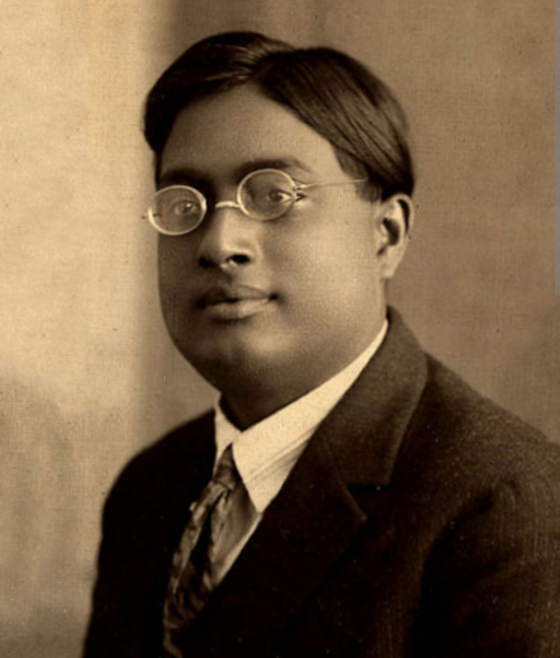

Satyendra Nath Bose (born January 1
1894, Calcutta [now Kolkata], India—died February 4, 1974, Calcutta) was an Indian mathematician and physicist noted for his collaboration with Albert Einstein in developing a theory regarding the gaslike qualities of electromagnetic radiation (see Bose-Einstein statistics).
Bose, a graduate of the University of Calcutta, taught at the University of Dacca (1921–45) and then at Calcutta (1945–56). Bose’s numerous scientific papers (published from 1918 to 1956) contributed to statistical mechanics, the electromagnetic properties of the ionosphere, the theories of X-ray crystallography and thermoluminescence, and unified field theory. Bose’s Planck’s Law and the Hypothesis of Light Quanta (1924) led Einstein to seek him out for collaboration.

